

*Dr/ Mohamed Ahmed Hussein  
Ta/ Shaimaa Tarek Hassan  
Name : Mahmoud Mohamed Mahmoud Desoky  
ID : 20182987*

Computer Networks – 1ITC 222 & DM222

Socket Programming Project

# ***Abstarct***

***Socket programming*** is a way of connecting two nodes on a network to communicate with each other. It is the Combination between an IP address & a port number. An end to end connection.

**Chatting Server**

A simple chatting application with one client and one server, Properties of your system:

* Be able to send a message to the server.
* The message should appear in both the server window and client window.
* The server should be able to respond to this message.
* The response should appear in both the server and client window.

**We using tcp protocol :**

* Not provided timming and minimum throughput
* Have connection oriented **Server code**

package socket.programming.project;

import java.io.BufferedReader;

import java.io.DataInputStream;

import java.io.DataOutputStream;

import java.io.IOException;

import java.io.InputStreamReader;

import java.net.ServerSocket;

import java.net.Socket;

public class Server {

public static void main(String[] args)throws IOException

{

String clientSentence;

String capitalizedSentence;

ServerSocket s = new ServerSocket(9999);

Socket ss = s.accept();

System.out.println("Connected");

DataInputStream in = new DataInputStream(ss.getInputStream());

DataOutputStream outToServer = new DataOutputStream(ss.getOutputStream());

BufferedReader br = new BufferedReader(new InputStreamReader(System.in));

while(true) {

String sentencefromclient = in.readUTF();

System.out.println("client: " + sentencefromclient);

String sentencetoclient = br.readLine();

outToServer.writeUTF(sentencetoclient);

if (sentencefromclient.equalsIgnoreCase("exist"))

{

break;

}

}

ss.close();

}

}  
  
  
  
  
  
  
  
  
  
  
  
  
  
  
  
  
**Client code**

package socket.programming.project;

import java.io.BufferedReader;

import java.io.DataInputStream;

import java.io.DataOutputStream;

import java.io.IOException;

import java.io.InputStreamReader;

import java.net.Socket;

public class Client {

public static void main(String[] args)throws IOException

{

Socket s = new Socket("localhost", 9999);

DataOutputStream outToServer = new DataOutputStream(s.getOutputStream());

DataInputStream in = new DataInputStream(s.getInputStream());

BufferedReader br = new BufferedReader(new InputStreamReader(System.in));

while(true)

{

String sentencetoclient = br.readLine();

outToServer.writeUTF(sentencetoclient);

String sentencefromserver = in.readUTF();

System.out.println("Server: " + sentencefromserver);

if(sentencetoclient.equalsIgnoreCase("exist"))

{

break;

}

}

s.close();

}

}  
  
  
  
  
  
  
  
  
  
  
  
  
  
  
**Shoots**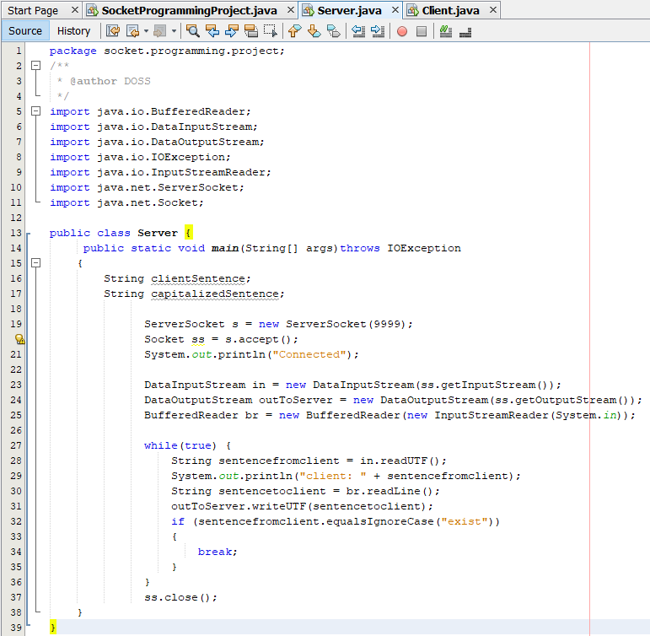

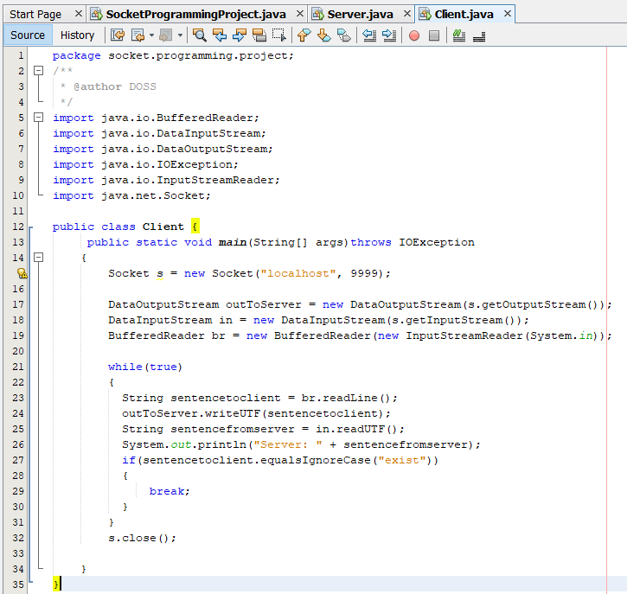

Output  
  
